SIMATS ENGINEERING
ASSESSMENT TOOL 1 - LOW (Coding Challenge)
COURSE CODE: CSA09 COURSE NAME: Programming in Java

Question 1: University Admission System using Method Overloading
CODE :
class Admission {

double calculateFee(double fee) {
return fee;
}

double calculateFee(double fee, double extraFee) {
return fee + extraFee;
}

double calculateFee(double fee, double scholarship, boolean scholarshipStudent) {
if (scholarshipStudent) {
return fee - scholarship;
}
return fee;
}

public static void main(String[] args) {

Admission a = new Admission();

System.out.println("Undergraduate Fee: Rs. " + a.calculateFee(50000));

System.out.println("Postgraduate Fee: Rs. "
+ a.calculateFee(50000, 15000));

System.out.println("Scholarship Student Fee: Rs. "
+ a.calculateFee(50000, 20000, true));
}
}

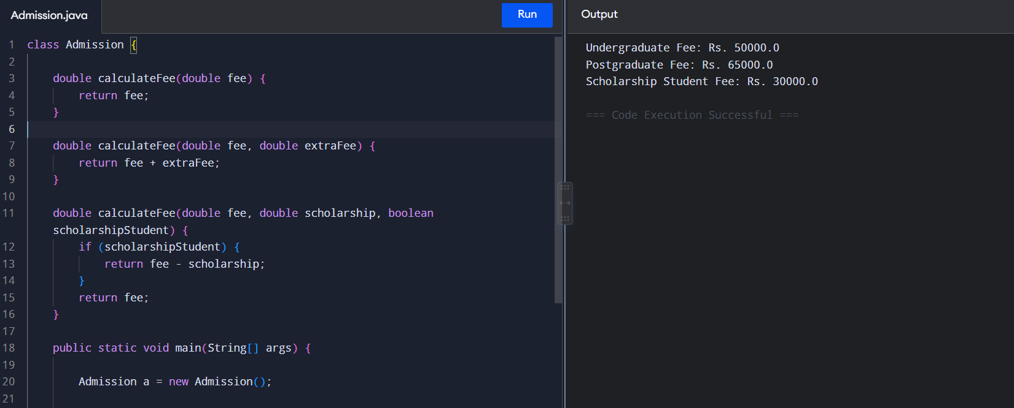
OUTPUT :
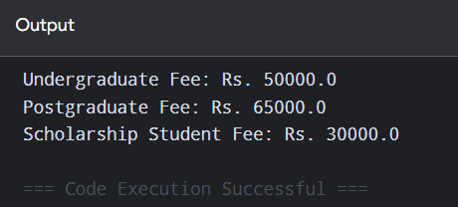

Question 2: Library Book Management :
CODE :
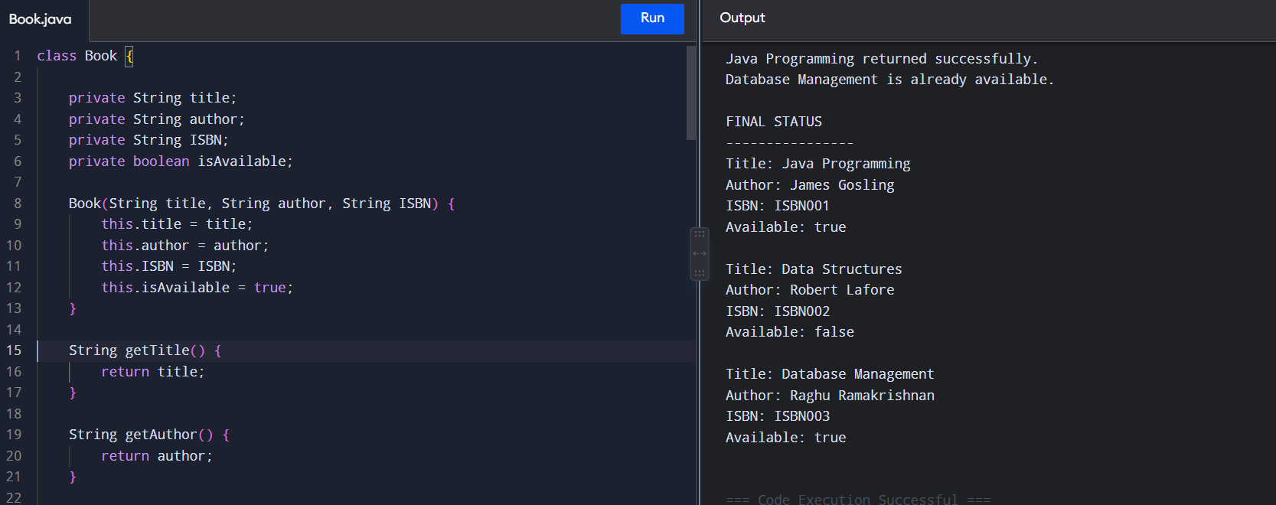

class Book {

private String title;
private String author;
private String ISBN;
private boolean isAvailable;

Book(String title, String author, String ISBN) {
this.title = title;
this.author = author;
this.ISBN = ISBN;
this.isAvailable = true;
}

String getTitle() {
return title;
}

String getAuthor() {
return author;
}

String getISBN() {
return ISBN;
}

boolean isAvailable() {
return isAvailable;
}

void issueBook() {
if (isAvailable) {
isAvailable = false;
System.out.println(title + " issued successfully.");
} else {
System.out.println(title + " is already issued.");
}
}
void returnBook() {
if (!isAvailable) {
isAvailable = true;
System.out.println(title + " returned successfully.");
} else {
System.out.println(title + " is already available.");
}
}
void displayDetails() {
System.out.println("Title: " + title);
System.out.println("Author: " + author);
System.out.println("ISBN: " + ISBN);
System.out.println("Available: " + isAvailable);
System.out.println();
}
public static void main(String[] args) {

Book book1 = new Book(
"Java Programming",
"James Gosling",
"ISBN001"
);

Book book2 = new Book(
"Data Structures",
"Robert Lafore",
"ISBN002"
);

Book book3 = new Book(
"Database Management",
"Raghu Ramakrishnan",
"ISBN003"
);

System.out.println("BOOK DETAILS");
System.out.println("----------------");

book1.displayDetails();
book2.displayDetails();
book3.displayDetails();

System.out.println("ISSUE OPERATIONS");
System.out.println("----------------");

book1.issueBook();
book2.issueBook();

book1.issueBook();

System.out.println("\nRETURN OPERATIONS");
System.out.println("----------------");

book1.returnBook();

book3.returnBook();
System.out.println("\nFINAL STATUS");
System.out.println("----------------");
book1.displayDetails();
book2.displayDetails();
book3.displayDetails();
}
}
OUTPUT :
